Code:-
package com.hospital;

import java.util.ArrayList;
import java.util.Scanner;

// ================= PERSON CLASS =================
abstract class Person {
String name;
int age;

Person(String name, int age) {
this.name = name;
this.age = age;
}

abstract void display();
}

// ================= PATIENT CLASS =================
class Patient extends Person {
String patientId;

Patient(String name, int age, String patientId) {
super(name, age);
this.patientId = patientId;
}

@Override
void display() {
System.out.println("Patient ID: " + patientId);
System.out.println("Name: " + name);
System.out.println("Age: " + age);
}
}

// ================= DOCTOR CLASS =================
class Doctor extends Person {
String specialization;

Doctor(String name, int age, String specialization) {
super(name, age);
this.specialization = specialization;
}

@Override
void display() {
System.out.println("Doctor Name: " + name);
System.out.println("Age: " + age);
System.out.println("Specialization: " + specialization);
}
}

// ================= APPOINTMENT CLASS =================
class Appointment {
String patientName;
String doctorName;

Appointment(String p, String d) {
patientName = p;
doctorName = d;
}

void show() {
System.out.println("Patient: " + patientName + " → Doctor: " + doctorName);
}
}

// ================= MAIN CLASS =================
public class HospitalManagementSystem {

static Scanner sc = new Scanner(System.in);

static ArrayList<Patient> patients = new ArrayList<>();
static ArrayList<Doctor> doctors = new ArrayList<>();
static ArrayList<Appointment> appointments = new ArrayList<>();

public static void main(String[] args) {

while (true) {

System.out.println("\n===== HOSPITAL MANAGEMENT SYSTEM =====");
System.out.println("1. Add Patient");
System.out.println("2. Add Doctor");
System.out.println("3. Book Appointment");
System.out.println("4. View Patients");
System.out.println("5. View Doctors");
System.out.println("6. Exit");

System.out.print("Enter choice: ");
int choice = sc.nextInt();
sc.nextLine();

switch (choice) {

case 1:
addPatient();
break;

case 2:
addDoctor();
break;

case 3:
bookAppointment();
break;

case 4:
viewPatients();
break;

case 5:
viewDoctors();
break;

case 6:
System.out.println("System Closed...");
return;

default:
System.out.println("Invalid Choice!");
}
}
}

// ========== ADD PATIENT ==========
static void addPatient() {
System.out.print("Enter Name: ");
String name = sc.nextLine();

System.out.print("Enter Age: ");
int age = sc.nextInt();
sc.nextLine();

String id = "P" + (patients.size() + 1);

patients.add(new Patient(name, age, id));

System.out.println("Patient Added Successfully!");
}

// ========== ADD DOCTOR ==========
static void addDoctor() {
System.out.print("Enter Name: ");
String name = sc.nextLine();

System.out.print("Enter Age: ");
int age = sc.nextInt();
sc.nextLine();

System.out.print("Enter Specialization: ");
String spec = sc.nextLine();

doctors.add(new Doctor(name, age, spec));

System.out.println("Doctor Added Successfully!");
}

// ========== BOOK APPOINTMENT ==========
static void bookAppointment() {

if (patients.isEmpty() || doctors.isEmpty()) {
System.out.println("Add Patients and Doctors first!");
return;
}

System.out.println("Select Patient:");
for (int i = 0; i < patients.size(); i++) {
System.out.println((i + 1) + ". " + patients.get(i).name);
}

int p = sc.nextInt();

System.out.println("Select Doctor:");
for (int i = 0; i < doctors.size(); i++) {
System.out.println((i + 1) + ". " + doctors.get(i).name);
}

int d = sc.nextInt();
sc.nextLine();

Appointment a = new Appointment(
patients.get(p - 1).name,
doctors.get(d - 1).name
);

appointments.add(a);

System.out.println("Appointment Booked!");
}

// ========== VIEW PATIENTS ==========
static void viewPatients() {
System.out.println("\n--- PATIENT LIST ---");
for (Patient p : patients) {
p.display();
System.out.println("------------------");
}
}

// ========== VIEW DOCTORS ==========
static void viewDoctors() {
System.out.println("\n--- DOCTOR LIST ---");
for (Doctor d : doctors) {
d.display();
System.out.println("------------------");
}
}
}

Output:-

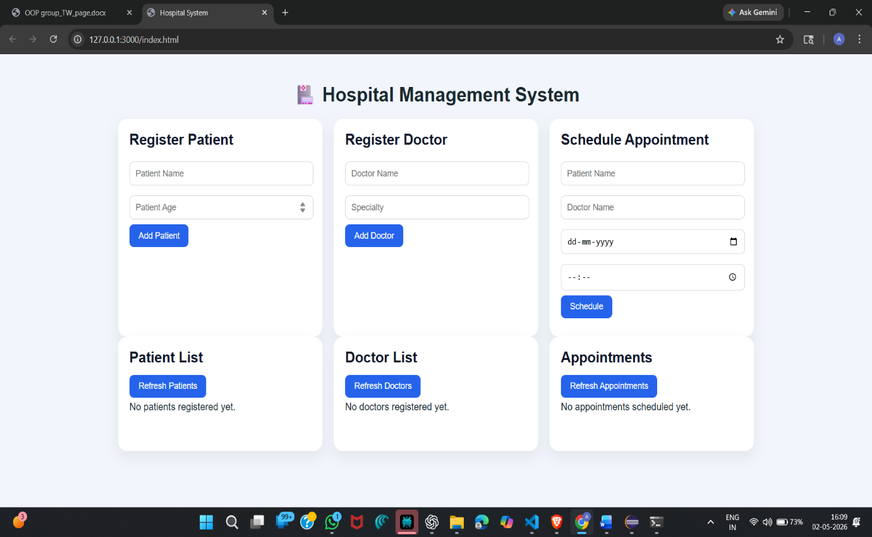

Class Diagram and Logical Flow Of Program:-

